Object Pool

The object pool is used to avoid constant instantiation and destruction of objects (which can take many resources over time). The pool object should be placed in all levels (except main menu). The interface is quite simple:

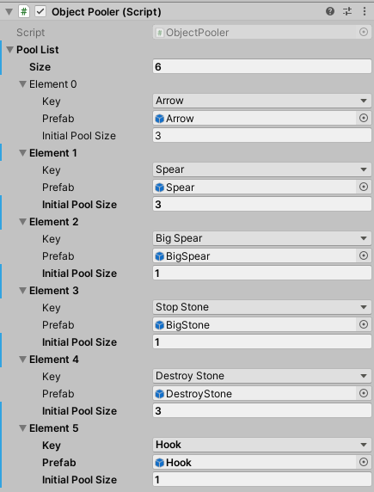

The key is chosen from a dropdown list (an Enum in code), a prefab has to be set as well as the initial pool size. When the game starts, X instances (*Initial Pool Size*) of *Prefab* will be created and hidden. If a new element has to be added, the Enum *PoolObjectKey*.cs will have to be expanded.

The pooler has two public methods:

* public GameObject PullObject(PoolObjectKey key) – returns an instance of the object listed under *key*. If there are no inactive objects at the moment of the request, a new instance will be created. The instantiated object is inactive therefore do not forget to set it to active after pulling it. In case no pool exists for the given *key*, the method returns null.
* public void PushObject(GameObject go, PoolObjectKey key) – sets the game object as inactive and returns it to the pool[*key*].